

LIFE12 ENV/IT/000374 PLASTIC KILLER

Questionnaire



Send to info@pal.it
COMPANY NAME: ________________________________________________________________________
ADRESS: ________________________________________________________________________________
POSTAL CODE: __________ TOWN: ________________________ COUNTRY: ________________________
JOB FUNCTION: ________________________________ E-MAIL: ___________________________________
N° OF YOUR STAFF: □ 0 – 50 employees
□ 51 – 100 employees
□ 150 – 500 employees
□ 501 – 1.000 employees
□ more than 1.000

YOU ARE :
- GOVERNMENTAL BODIES /RESEARCH AND EDUCATIONAL INSTITUTIONS DEALING WITH RECYCLING, FORESTRY AND WOOD USAGE □ YES

- WIDER AUDIENCE □ YES

- MANUFACTURES OF: □ PARTICLE BOARDS
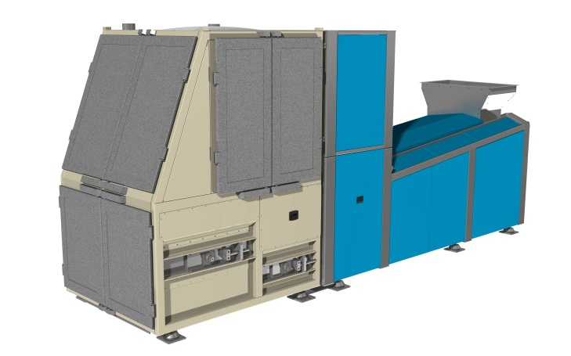
□ MDF
□ OSB
□ MDF
□ PELLET
□ PALLET BLOCKS
□ INSULATION BOARD
□ BIOMASS

CAPACITY OF YOUR PLANT: …………t/h ……… m³/h

- Impact of plastics on your process (only for MANUFACTURERS) :
- Do they affect the quality of the panelboard?
If so, please, indicate which property they affect;
□ surface quality
□ lacquering operation
□ laminate coating
□ mechanical properties

- Do they affect some specific phase of your process?
If so, please indicate which;
□ refining operation
□ coating operation
□ forming operation
□ blending operation

- Do they prevent the use of wood as a fuel/biomass?
If so, please say why;
□ dioxin emission
□ furans emission
□ low NCV (net calorific value)
2. Content of plastics in your material (only for MANUFACTURERS):
% of plastic: □ 0% – 5%
□ 6% - 8%
□ 9% - 15%
□ 16% - 25%
□ > 25%
kind of plastic:______
- Amount of material you need to clean (only for MANUFACTURERS):
- What is the amount/flow rate of material you need to clean from plastics?
□ < 1 ton/h
□ > 1 ton/h, < 3 ton/h
□ > 3 ton/h, < 10 ton/h
□ > 10 ton/h

- What is the level of cleaning of material you need?
□ > 95%
□ > 97%
□ > 99%
□ > 99,5%

- Your expectations about the performances of the machine removing plastics:
percentage of purity of the final material ______
maximum percentage of wood loss ______
Maximum power consumption (kW/ton/h)______

- Main problems\issues\constraints you found in wood recycle and re-use:
□ low quality of the final product
□ high quantity of the wood loss during the recycling process
□ high costs of the recycling process
□ ….

I’m interested to receive info about PLASTIC KILLER □ yes □ no

Date___________ Signature____________________________

Send to info@pal.it

